1325 JET PRO MODEL
WHAT IS 1325 JET PRO: - 1325” indicates the working area of the machine, which is 1300 mm × 2500 mm. It is our heaviest and most powerful model, designed to handle a wide range of materials with ease.
SPECIFICATIONS: -
- WORKING AREA: - Our 1325 Jet Pro model comes with a machine bed size of 1300 mm × 2500 mm, which is approximately 8 × 4 feet.
Why do we provide an 8 × 4 feet bed size? The reason is that plywood, MDF, and acrylic sheets are commonly available in the standard 8 × 4 feet size. This allows you to place the entire sheet directly on the machine bed and start working without having to cut or adjust the material first.
As a result, you don't have to worry about material handling or unnecessary material wastage, and your overall production process becomes faster and more efficient.
Additionally, if a customer has a requirement for a different working size—for example, 10 × 5 feet instead of 8 × 4 feet—we can also provide a customized machine bed according to their specific requirements.
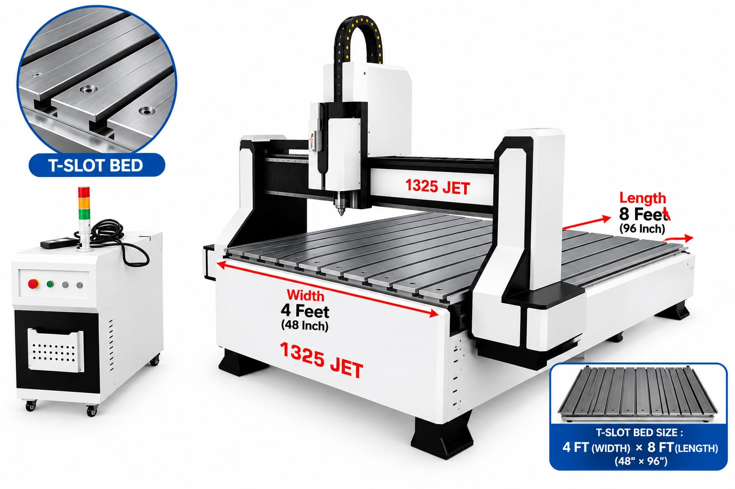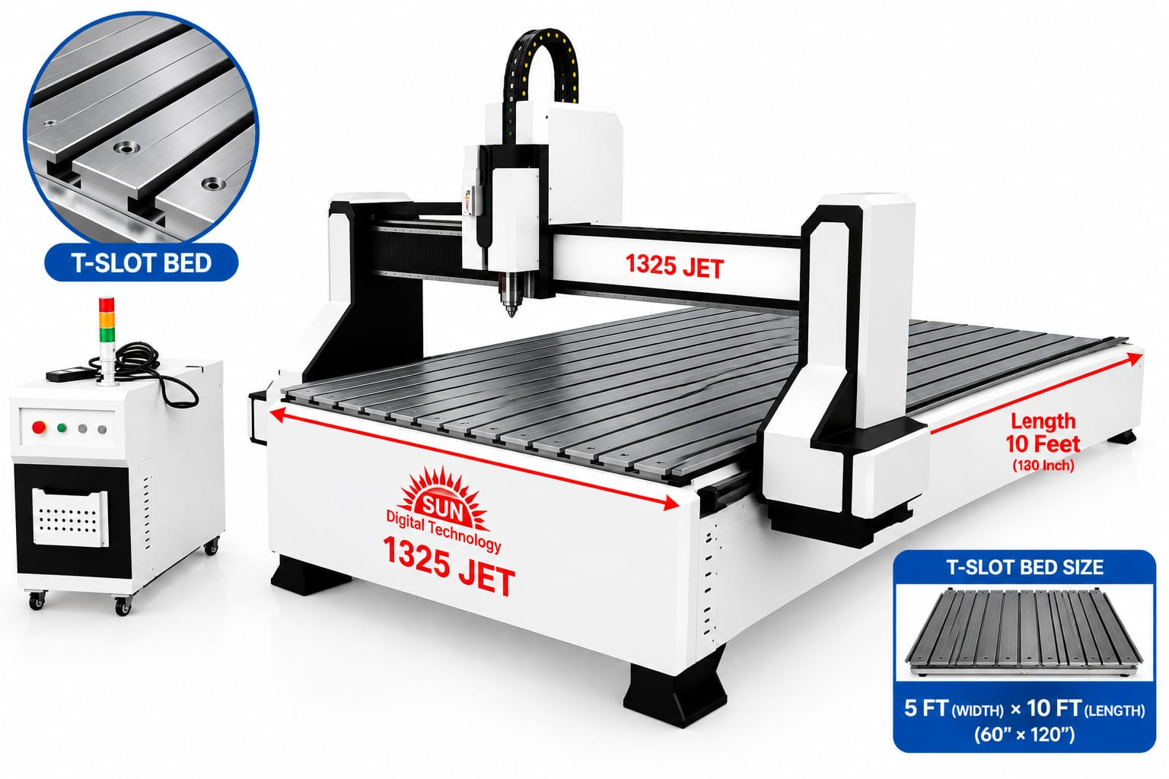
- MACHINE POWER: - This machine comes with an 8 kW or 9.5 HP power.
What is the role of horsepower?
Horsepower simply tells us how powerful the machine is. The higher the HP, the more powerful the machine will be.
With higher HP, the machine can easily cut deeper and tougher materials without any difficulty.
- Z TRANSMISSION: -
This machine comes with a 25 mm Taiwan-made Z-axis ball screw from reputed brands such as TBI Motion Technology or HIWIN Technology.
The 25 mm ball screw makes the machine strong and heavy-duty, while the braking system helps hold the spindle in position.
This is especially useful when the power is off or when you are doing high-precision work, as it helps maintain the spindle position accurately.
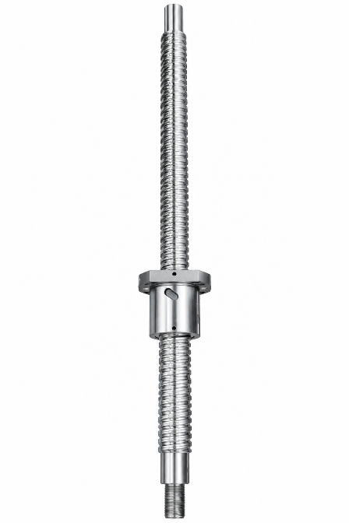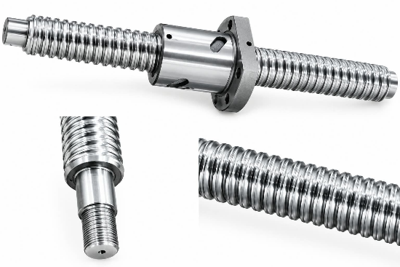
- TABLE STRUCTURE: - We have designed and built the table of this machine using cast steel.
The main reason for using cast steel is to make the machine more rigid and stable. This helps reduce vibrations when the machine is doing heavy-duty work.
It also makes the machine stronger and more durable, helping it performs reliably for a long time.
- BED STRUCTURE: - We have designed the bed structure using a T-slot aluminium table with a hard PVC layer.
The T-slots provide flexible clamping, so you can easily place and securely fix your board on the table.
We have also added a rigid PVC layer to support the bed, making the table more rigid and durable.
As an option, we also provide a vacuum bed and a pneumatic press roller, depending on the customer’s requirements.
If a customer requires a vacuum bed, we can customize and provide it accordingly.
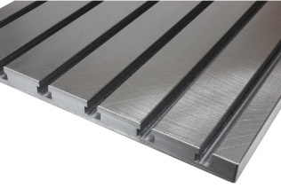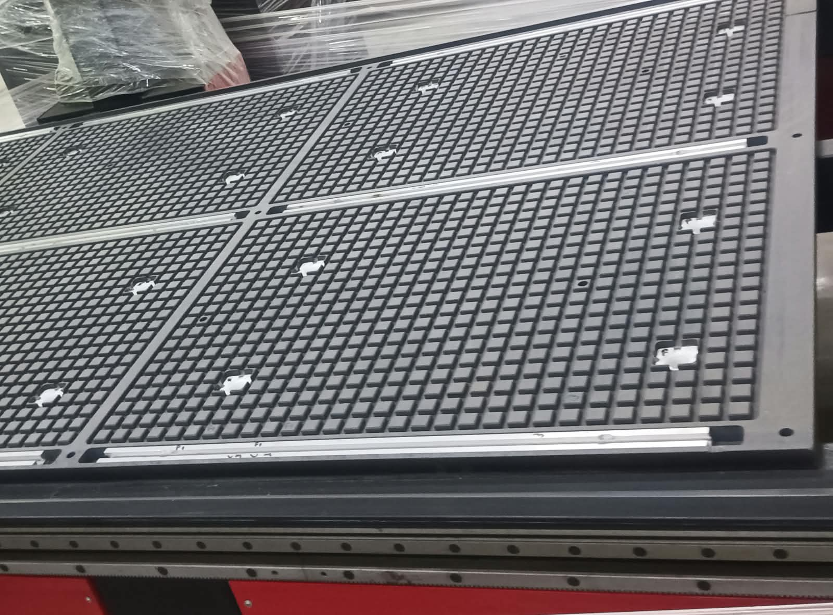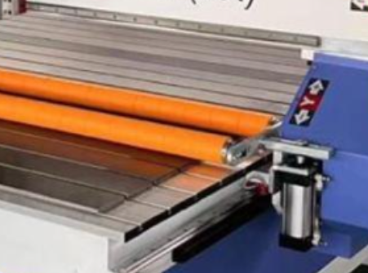
- SPINDLE POWER: - The 1325 Jet Pro model is equipped with a 6 KW air-cooled spindle, designed to deliver high performance and reliable cutting for demanding applications.
This powerful spindle helps the machine handle heavy cutting and carving operations while maintaining a good working speed. It also provides smooth and stable performance, making it suitable for continuous production.
The spindle is manufactured by HSD, an Italian-based company, known for its high-quality industrial spindle technology.
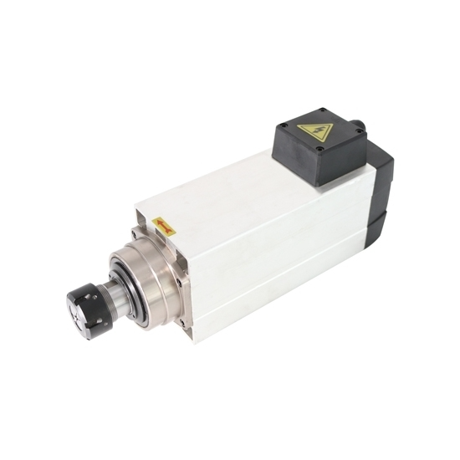
- SPINDLE SPEED: - The 1325 Jet Pro model offers a spindle speed range of 18,000 to 24,000 RPM, giving you the flexibility to adjust the speed according to the material and type of work.
For fine carving and clean finishing, a higher speed of up to 24,000 RPM is ideal, especially for materials like MDF and acrylic. It helps achieve smoother detailing and a cleaner surface finish.
For heavy cutting, extremely high RPM is not always required. A speed of around 18,000 RPM can be suitable for cutting applications, depending on the material, tool, and cutting depth.
XY TRANSMISSION: -
We use 1.25 mm rack gear system in our 1325 JET PRO that moves the cutting head from left to right and front to back. Helical gears are slightly angled gear teeth, which gives smooth motion, low vibration, and solid performance at the high speed. | 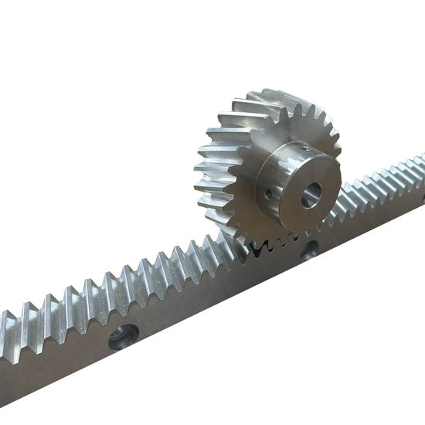
- GUIDE RAIL: - One of the most important components of any machine is its guide rail.
In the Sun 1325 Jet Pro, you get a heavy-duty 25 mm guide rail, which is Made in Germany [Schneeberger].
The motors and other components of a machine provide it with power, but the guide rail is what gives the machine straight and precise directional movement.
While many other machines provide guide rails of up to 20 mm, Sun Digital offers a 25 mm guide rail. This helps the machine handle the load of heavy components while maintaining proper accuracy.
The strong guide rail minimizes shaking and twisting, ensuring that the machine maintains its accuracy during operation. It also provides smooth and stable movement, especially during spindle movement.
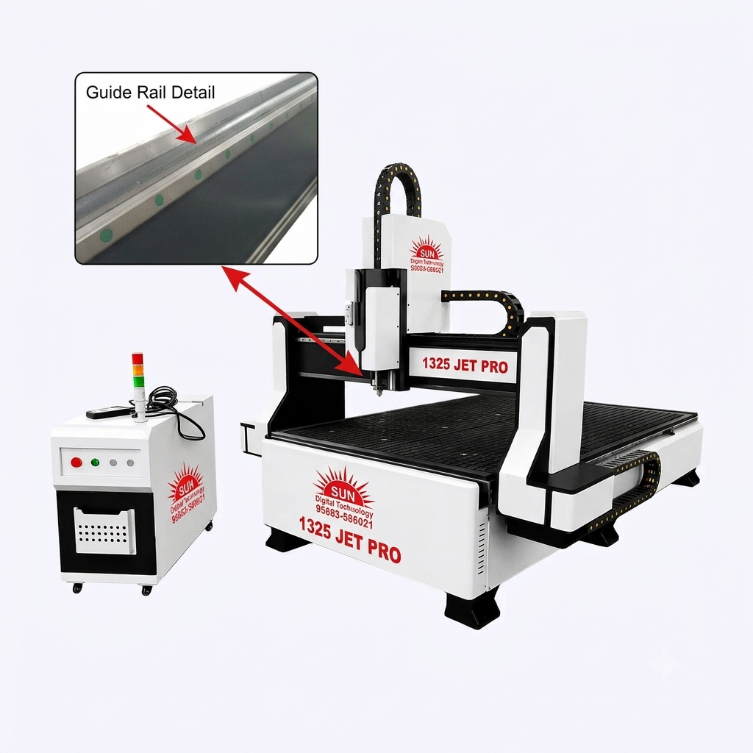
- DRIVE: - Among full servo drives, hybrid drives, and stepper drives, the full servo drive is the best option. It comes with an encoder feedback system that continuously monitors the position and corrects it whenever required. This makes high-speed movement smoother and improves machine reliability.
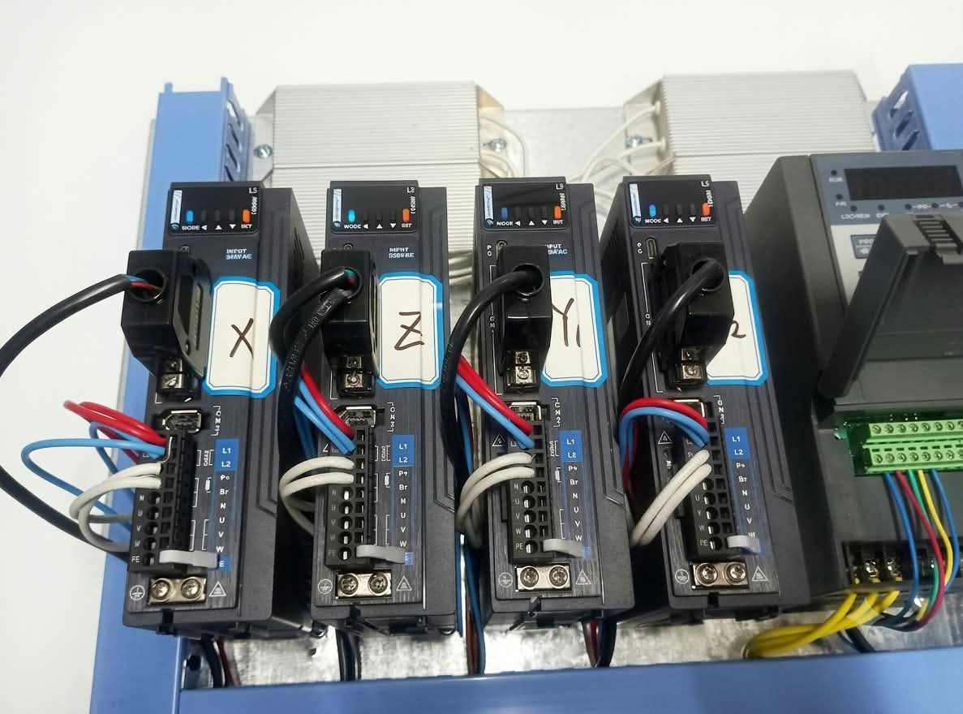
It also helps detect upcoming errors or position deviations in advance. The drive continuously monitors the machine’s position and automatically corrects it whenever necessary, ensuring accurate and reliable operation.
- MOTOR: -Stepper motors carry a risk of missing steps under heavy load. In contrast, a full servo system utilizes a feedback system to continuously detect positioning errors and correct them automatically, making the movement significantly more precise and suitable.
​This system is equipped with a 1.5 kW motor, ensuring adequate power to easily handle high-speed movements across an 8x4 gantry. The machine delivers a torque power of 4.9 Nm of rotational force. 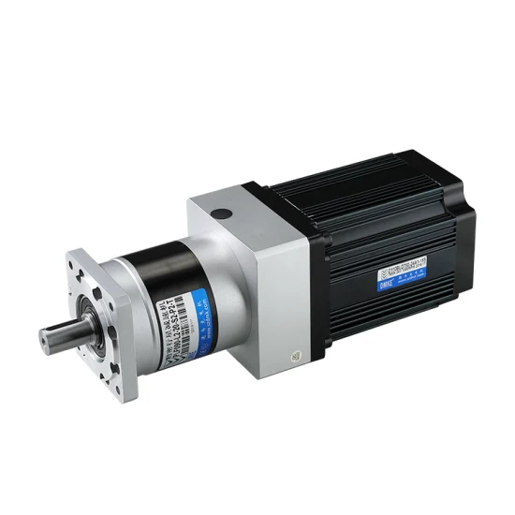 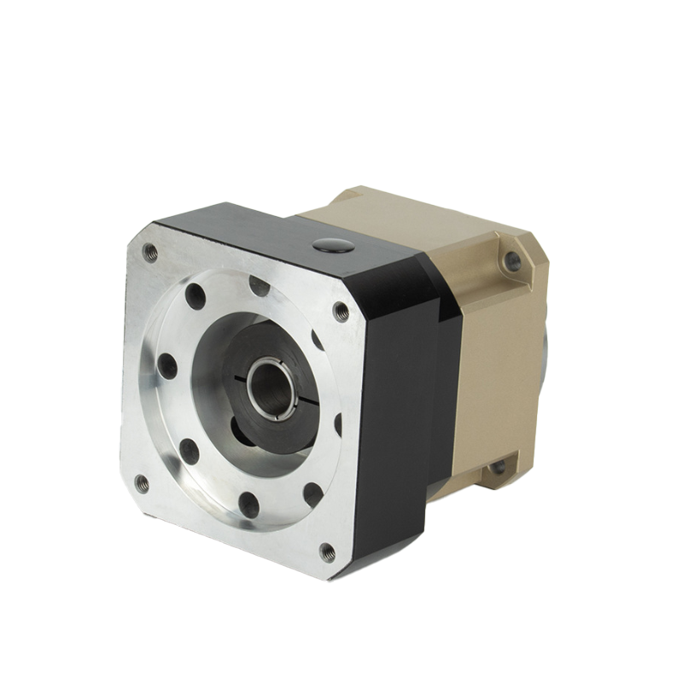
PLANETARY GEAR BOX: - With a fully servo motor, you are provided with a planetary gearbox. So, what does the gearbox actually do?
First of all, most models come with a belt system. We have replaced that belt system with a gear system.
If you are using a belt system, depending on the weather and working conditions, you may need to replace it from time to time. Sometimes, the belt can even break, and you have to replace it.
On the other hand, if you install a gear system, you don’t face these kinds of issues. There is no need for frequent replacement.
Plus, if you are working with a belt system, 2D or 3D carving may take around 6 to 7 hours. But with a gear system, the same work can be completed in around 3 hours.
CONTROLLER: - The NK 105 G2 controller is provided with the 1325 Jet Pro model. It allows you to upload G-code files directly from a USB drive to the controller and operate the machine seamlessly. It features a breakpoint resume function that automatically restores operation from where the design stopped in case of a power outage. Additionally, you can adjust the feed rate during operation, and it supports multi-workpiece coordinate systems.
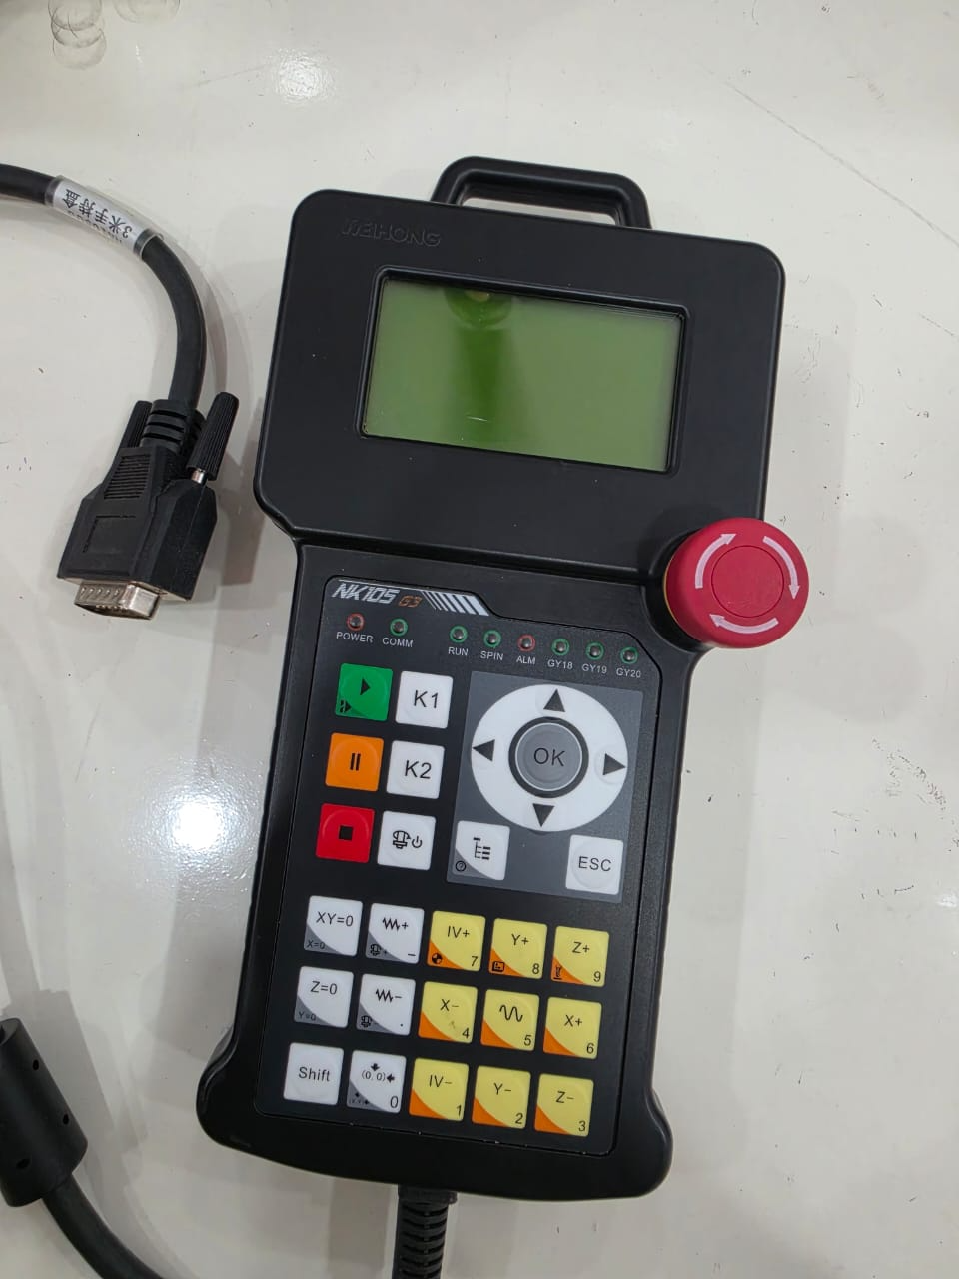

MACHINE ACCURACY: - The most important element in production is accuracy. The Sun Digital 1325 jet Pro model offers machine accuracy of less than 0.01 mm. This means that whenever you repeat any design or carving, you get consistent and precise results every time. This high level of accuracy not only ensures better quality but also helps make the production process faster and more efficient.
INVERTER: - With the 1325 JET Pro model, you get a Rituo brand VFD (Variable Frequency Drive). It provides better control over the spindle speed, ensuring smooth operation and improving the overall performance of the machine.
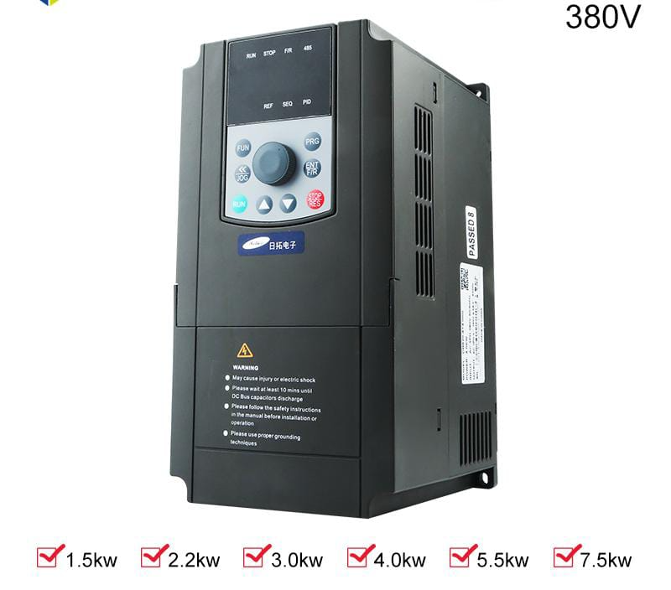
The VFD helps the machine operate more efficiently and provides stable and consistent performance during the production process.
PROGRAMMING: - The machine uses G-code programming, which ensures accurate and precise movements. It helps reduce human errors, makes repeated production more consistent, and saves production time. Overall, G-code programming improves the machine’s efficiency, accuracy, and productivity.
PHASE: - This model operates on a three-phase, 380-volt power supply. This helps distribute the electrical load more efficiently and can result in lower power consumption and better energy efficiency.
SOFTWARE: - The standard software we use is ARTCAM, because it is very easy to use. So, if someone is starting their business or operating a CNC machine for the first time, ARTCAM is easy to learn and operate.
Apart from ArtCam, we also provide software such as AutoCut, CatCam depending on the requirement.
INDICATER: - Sun Digital provides an indicator with the machine to monitor and analyze electricity fluctuations, helping identify voltage variations and protect the machine from potential electrical issues.
3 tier LED signal tower light features red, yellow, reen light.
Red indicates a critical error or a hard stop.
Yellow indicates a temporary pause, a warning condition
Green indicates normal running status
Oil pump: - manual oil lubrication system
ACCESSORIES: - 10 TYPES OF BITS, FULL SET SPINDLE NUT, SENSOR
